CLASS TEST-I
SUBJECT: COMPUTER SCIENCE
TOTAL MARKS: 15
__________________________________________________________
Name the following:
1. What is the original name of JavaScript?

2. Which tag is used to embed external JavaScript into HTML web page?

3. Name the first robot to use AI to navigate.

4. Which app uses the GPS location of the Smartphone to collect information about the user’s surroundings?

5. Name the virtual assistant of Microsoft.

6. Write a program using JavaScript to take input of distance in meter and convert to km.

7. Find the output:
i)
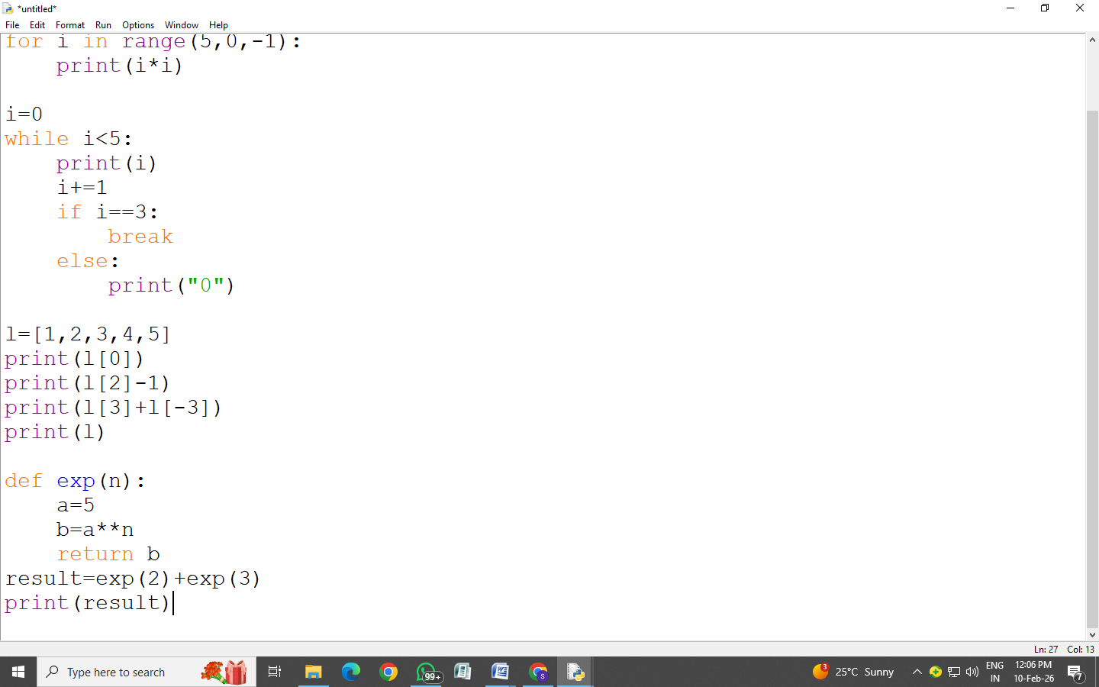
ii)
iii)
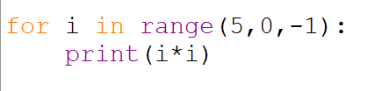

iv)

